1. 
2. It is time add documents to cluster.
3. Elasticsearch exposes API and we have to use the HTTP verbs to specify the action we want to perform on index.
4. **Agenda**:
   1. How to create and index.
   2. How to configure shards and replica shards while creating index.
5. **Command** 🡺 **To delete an index **
6. Let’s add a new index “products”:
7. **Command** 🡺 **To add an index’**
   1. Instead of using the default settings, we want to specify the no of shards and the no of replica.  
      In production, we stick to the default values from configuration file but for demonstration purpose we’re doing so.
   2. To specify the index settings (index configuration), we need to include a request body that is a JSON.
   3. 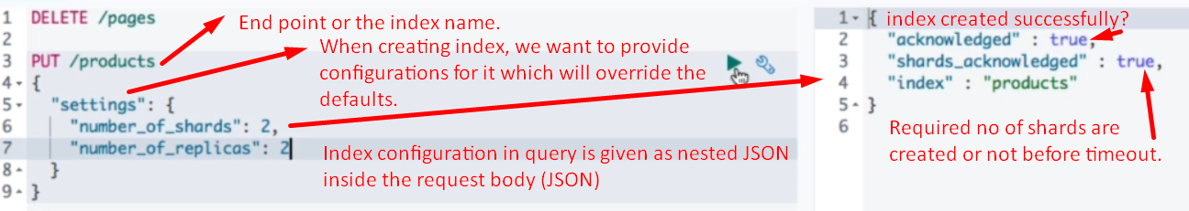 **settings: To specify the index settings.**  
      **acknowledged**:true 🡸 whether the index was created successfully or not.  
      **shards_ acknowledged**:true🡸 whether or not the required number shards started up before the timeout. By **default** it refers to the primary shards.
8. 
9. **Observation by Jatin Starts:**  
   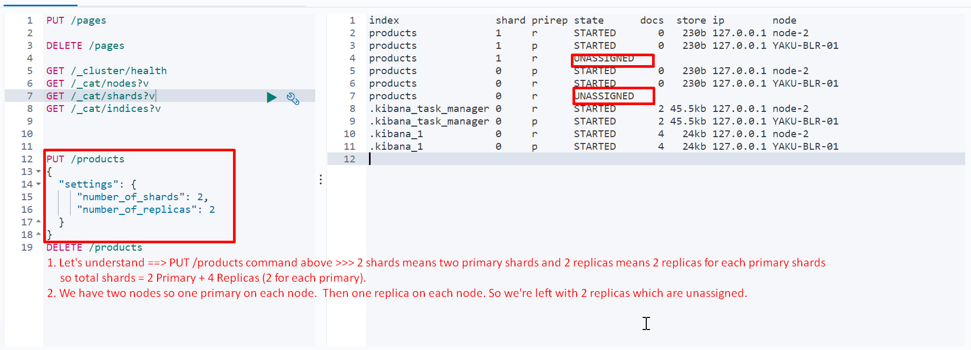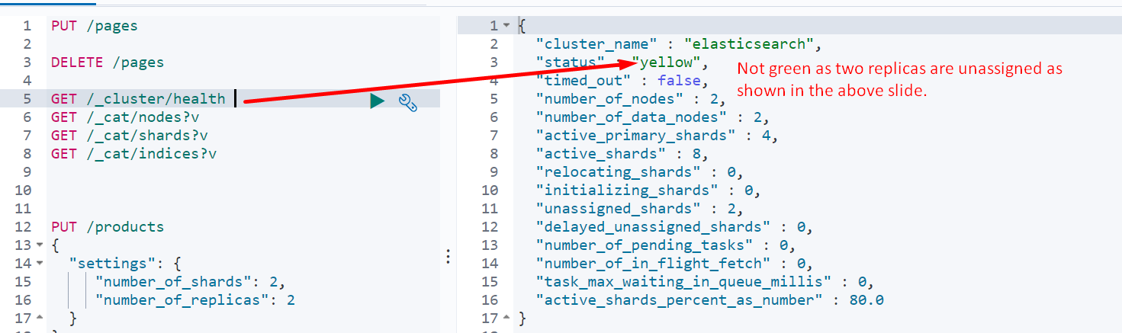  
   **Observation by Jatin Ënds:**